What Exactly Happened with Banks After JPMorgan's Q3 2025 Earnings?

JPMorgan Chase kicked off bank earnings pre-market on October 14 with a double beat on both revenue and profit, yet its stock drifted lower through the week—closing under $300 by Friday. The decline wasn’t driven by company fundamentals alone but by a mix of macro headwinds, sector-wide anxiety, and market psychology that punished the broader financial space.

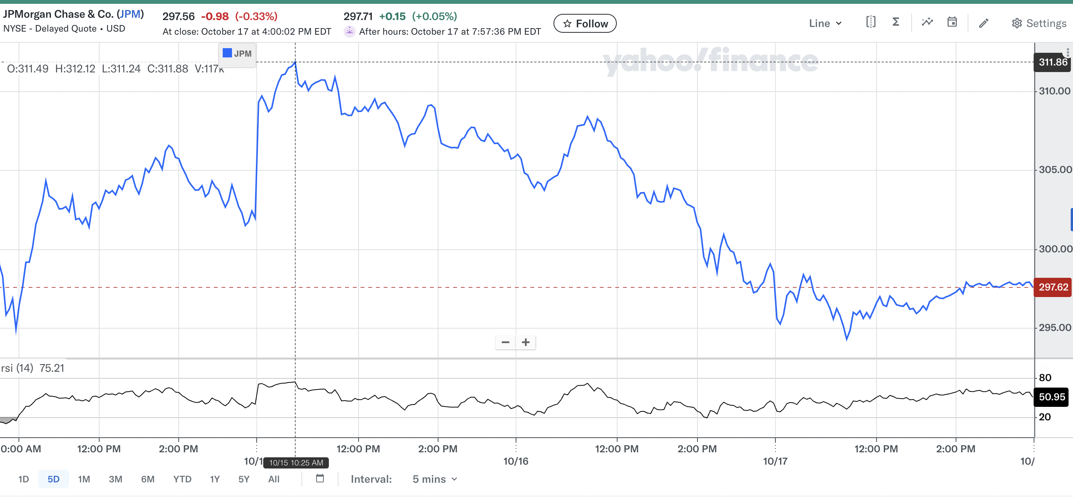

Chart: Yahoo Finance (JPMorgan Stock Performance Week of Oct 12-18, 2025)

# Strong Quarter, Shaky Outlook

JPMorgan reported another strong quarter, supported by robust performance in its investment banking and trading divisions. The bank raised its full-year net interest income (NII) forecast to roughly $95.8 billion, according to Reuters and CNBC coverage. That signaled core banking operations were still benefiting from a high-rate environment. However, much of Q3’s upside came from investment and markets revenue—a volatile segment that investors often discount as less stable than consumer or commercial banking.  
  
CEO Jamie Dimon added to market unease with another round of stark macro warnings. He reiterated concerns about the growing U.S. national debt, heavy reliance on consumer credit, and a potential market correction within the next two years. Dimon also cited signs of strain in consumer credit quality and pointed to geopolitical uncertainty—including major U.S. debt holders like China, Japan, and South Korea selling Treasury securities, a move many analysts interpret as a loss of confidence in U.S. fiscal discipline. Dimon even floated the risk of stagflation if productivity gains from AI underdeliver.

# Sector Turmoil: Cockroaches and Collateral

The optimism from JPM’s results quickly faded as the week unfolded. News broke that subprime auto lender Tricolor Holdings and auto parts supplier First Brands Group had collapsed, exposing credit losses for several regional lenders. Dimon’s metaphor about there being “more cockroaches” when one appears became a talking point across Wall Street.  
  
Shortly after, Zions Bancorporation disclosed a $50 million charge-off tied to two commercial borrowers, sending its shares down nearly 5%. The KBW Regional Banking Index tumbled roughly 4.8%, its worst single-day drop since April. According to MarketWatch and Reuters, the losses were driven by fear of hidden credit risks spreading through smaller banks.  
  
At the same time, Western Alliance Bancorporation filed a lawsuit against a borrower over alleged fraudulent collateral but maintained that its collateral position remains sufficient and its 2025 guidance unchanged, a signal that not every headline risk spelled contagion. Meanwhile, Fifth Third Bank took a $178 million loan-loss charge connected to Tricolor but still reported solid underlying earnings (Barron’s, Oct. 17).

# Macro Fear Meets Overreaction

Taken together, these incidents triggered a classic sentiment overreaction. Analysts broadly agree that the failures of Tricolor and First Brands were non-systemic, meaning they don’t threaten the stability of the financial system—yet they shook confidence in how well banks are monitoring credit exposures.  
  
Adding fuel to the fire, Trump’s proposed 100% tariff on Chinese imports added volatility before he clarified that such a move was “not sustainable.” Treasury Secretary Scott Bessent was also reported to be meeting with Chinese officials to de-escalate tensions. These developments suggested that, while global credit trust may be strained, policymakers are actively preventing escalation.

# A Buyable Dip?

Despite the bearish sentiment, several metrics argue for cautious optimism. JPMorgan’s valuation has pulled back, with shares under $300 while the average analyst price target hovers around $325 and over 60% of analysts rate it a buy (MarketBeat). According to Simply Wall St, the bank’s discounted cash flow (DCF) valuation implies a fair value closer to $360 per share, underscoring potential upside if macro fears stabilize. The bank’s proactive decision to raise credit-loss allowances should also be read as prudence, not weakness—a buffer against potential softness in consumer spending and lower rates.  
  
With alternative assets posting record-breaking YTD returns, consumer spending resilient heading into the holiday season, and Q4 earnings expected to show strength in goods, services, and BNPL sectors, the macro backdrop isn’t uniformly bleak. Combined with JPM’s ongoing investment initiatives in national security and technology infrastructure, the setup looks favorable for a short-term rebound in large-cap financials if Q4 results reinforce the resilience seen so far.

# Outlook

Volatility and geopolitics make any long-term call risky. Still, the factors behind this week’s drop—non-systemic bankruptcies, heightened credit scrutiny, and sector-wide nerves—don’t fundamentally undermine JPMorgan’s franchise strength. If anything, they create space for a short-term sentiment-driven rally as markets recalibrate heading into year-end.

This article is for informational purposes only and does not constitute investment advice.

Sources: Reuters, MarketWatch, Barron’s, The Guardian, CNBC, InvestmentNews, MarketBeat, Simply Wall St (Oct. 14–19, 2025).